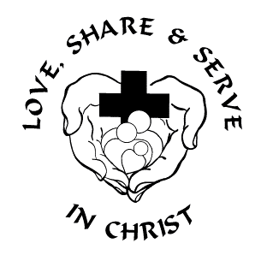
Messiah Evangelical Lutheran Church
6

402 N. First Street, Lindsborg, KS. 67456
Office: 785-227-3977 www.melclindsborg.org mlchurch@mlc.kscoxmail.com
June 21, 2020 ELW Holy Communion Setting Eight
Please practice your highest regard for your family in Christ by following social distancing, wearing a mask, not singing, and washing your hands. Seating is marked to allow those you consider “in your bubble” to sit with you. Thank you.
PRELUDE Prelude and Fugue in E Minor JS Bach

ANNOUNCEMENTS:

GATHERING
The Holy Spirit calls us together as the people of God. Amen

CONFESSION AND FORGIVENESS
Blessed be the holy Trinity, ☩ one God, whose steadfast love is everlasting, whose faithfulness endures from generation to generation. Amen. Trusting in the mercy of God, let us confess our sin. Silence is kept for reflection. Reconciling God,
we confess that we do not trust your abundance, and we deny your presence in our lives. We place our hope in ourselves and rely on our own efforts. We fail to believe that you provide enough for all. We abuse your good creation for our own benefit. We fear difference and do not welcome others as you have welcomed us. We sin in thought, word, and deed. By your grace, forgive us; through your love, renew us; and in your Spirit, lead us; so that we may live and serve you in newness of life. Amen.
Beloved of God, by the radical abundance of divine mercy we have peace with God through ☩ Christ Jesus, through whom we have obtained grace upon grace. Our sins are forgiven. Let us live now in hope. For hope does not disappoint, because God’s love has been poured into our hearts through the Holy Spirit. Amen.
OPENING HYMN ELW #660

GREETING
The grace of our Lord Jesus Christ, the love of God, and the communion of the Holy Spirit be with you all. And also with you.
KYRIE

Canticle of Praise

Prayer of the Day
Teach us, good Lord God, to serve you as you deserve, to give and not to count the cost, to fight and not to heed the wounds, to toil and not to seek for rest, to labor and not to ask for reward, except that of knowing that we do your will, through Jesus Christ, our Savior and Lord. Amen.

Genesis 21:8-21
Sarah demands that Abraham send Hagar and her son, Ishmael, away. Abraham is distressed because he is Ishmael’s father. Sarah wants to ensure that her son, Isaac, will be the one to inherit God’s blessing. God, however, hears Hagar’s cry and promises to also make of Ishmael a great nation.
⁸The child [Isaac] grew, and was weaned; and Abraham made a great feast on the day that Isaac was weaned. ⁹But Sarah saw the son of Hagar the Egyptian, whom she had borne to Abraham, playing with her son Isaac. ¹⁰So she said to Abraham, “Cast out this slave woman with her son; for the son of this slave woman shall not inherit along with my son Isaac.” ¹¹The matter was very distressing to Abraham on account of his son. ¹²But God said to Abraham, “Do not be distressed because of the boy and because of your slave woman; whatever Sarah says to you, do as she tells you, for it is through Isaac that offspring shall be named for you. ¹³As for the son of the slave woman, I will make a nation of him also, because he is your offspring.” ¹⁴So Abraham rose early in the morning, and took bread and a skin of water, and gave it to Hagar, putting it on her shoulder, along with the child, and sent her away. And she departed, and wandered about in the wilderness of Beer-sheba.
¹⁵When the water in the skin was gone, she cast the child under one of the bushes. ¹⁶Then she went and sat down opposite him a good way off, about the distance of a bowshot; for she said, “Do not let me look on the death of the child.” And as she sat opposite him, she lifted up her voice and wept. ¹⁷And God heard the voice of the boy; and the angel of God called to Hagar from heaven, and said to her, “What troubles you, Hagar? Do not be afraid; for God has heard the voice of the boy where he is. ¹⁸Come, lift up the boy and hold him fast with your hand, for I will make a great nation of him.” ¹⁹Then God opened her eyes and she saw a well of water. She went, and filled the skin with water, and gave the boy a drink.
²⁰God was with the boy, and he grew up; he lived in the wilderness, and became an expert with the bow. ²¹He lived in the wilderness of Paran; and his mother got a wife for him from the land of Egypt.
Word of God, Word of Life. Thanks be to God.

Psalm 69:7-10 [11-15] 16-18
Answer me, O Lord, for your love is kind. (Ps. 69:16)
⁷Surely, for your sake I have suffered reproach, and shame has covered my face.
⁸I have become a stranger to my own kindred, an alien to my mother’s children.
⁹Zeal for your house has eaten me up; the scorn of those who scorn you has fallen upon me.
¹⁰I humbled myself with fasting, but that was turned to my reproach.
¹¹I put on sackcloth also, and became a by word among them.
¹²Those who sit at the gate murmur against me,
and the drunkards make songs about me.
¹³But as for me, this is my prayer to you, at the time you have set, O Lord: “In your great mercy, O God, answer me with your unfailing help.
¹⁴Save me from the mire; do not let me sink; let me be rescued from those who hate me and out of the deep waters.
¹⁵Let not the torrent of waters wash over me, neither let the deep swallow me up; do not let the pit shut its mouth upon me.
¹⁶Answer me, O Lord, for your love is kind; in your great compassion, turn to me.
¹⁷Hide not your face from your servant; be swift and answer me, for I am in distress.
¹⁸Draw near to me and redeem me; because of my enemies deliver me.

Second Reading: Romans 6:1b-11
In baptism we were incorporated into the reality of Christ’s death and resurrection. We have been made new in Christ through his death and resurrection to live freed from sin.
^{1b}Should we continue in sin in order that grace may abound? ²By no means! How can we who died to sin go on living in it? ³Do you not know that all of us who have been baptized into Christ Jesus were baptized into his death? ⁴Therefore we have been buried with him by baptism into death, so that, just as Christ was raised from the dead by the glory of the Father, so we too might walk in newness of life. ⁵For if we have been united with him in a death like his, we will certainly be united with him in a resurrection like his. ⁶We know that our old self was crucified with him so that the body of sin might be destroyed, and we might no longer be enslaved to sin. ⁷For whoever has died is freed from sin. ⁸But if we have died with Christ, we believe that we will also live with him. ⁹We know that Christ, being raised from the dead, will never die again; death no longer has dominion over him. ¹⁰The death he died, he died to sin, once for all; but the life he lives, he lives to God. ¹¹So you also must consider yourselves dead to sin and alive to God in Christ Jesus.
Word of God, Word of Life. Thanks be to God.

Gospel Acclamation

Gospel: Matthew 10:24-39

Glory to you, O Lord.
Jesus warns his disciples that their ministry in his name will meet with opposition. However, he assures them that they need not fear for the truth will come to light. Life is found in Christ.
[Jesus said to the twelve:] ²⁴“A disciple is not above the teacher, nor a slave above the master; ²⁵it is enough for the disciple to be like the teacher, and the slave like the master. If they have called the master of the house Beelzebul, how much more will they malign those of his household! ²⁶“So have no fear of them; for nothing is covered up that will not be uncovered, and nothing secret that will not become known. ²⁷What I say to you in the dark, tell in the light; and what you hear whispered, proclaim from the housetops. ²⁸Do not fear those who kill the body but cannot kill the soul; rather fear him who can destroy both soul and body in hell. ²⁹Are not two sparrows sold for a penny? Yet not one of them will fall to the ground apart from your Father. ³⁰And even the hairs of your head are all counted. ³¹So do not be afraid; you are of more value than many sparrows. ³²“Everyone therefore who acknowledges me before others, I also will acknowledge before my Father in heaven; ³³but whoever denies me before others, I also will deny before my Father in heaven. ³⁴“Do not think that I have come to bring peace to the earth; I have not come to bring peace, but a sword. ³⁵For I have come to set a man against his father, and a daughter against her mother, and a daughter-in-law against her mother-in-law; ³⁶and one’s foes will be members of one’s own household. ³⁷Whoever loves father or mother more than me is not worthy of me; and whoever loves son or daughter more than me is not worthy of me; ³⁸and whoever does not take up the cross and follow me is not worthy of me. ³⁹Those who find their life will lose it, and those who lose their life for my sake will find it.”
The gospel of the Lord. Praise to you, O Christ.

SERMON Pastor Amy

APOSTLES’ CREED
I believe in God, the Father almighty, creator of heaven and earth.
I believe in Jesus Christ, God’s only Son, our Lord, who was conceived by the Holy Spirit, born of the virgin Mary, suffered under Pontius Pilate, was crucified, died, and was buried; he descended to the dead. On the third day he rose again; he ascended into heaven, he is seated at the right hand of the Father, and he will come to judge the living and the dead.
I believe in the Holy Spirit, the holy catholic church, the communion of saints, the forgiveness of sins, the resurrection of the body, and the life everlasting. Amen.

Prayers of Intercession
Called into unity with one another and the whole creation, let us pray for our shared world.
A brief silence.
Expansive God, you bring diverse voices together to form your church. Open our hearts and unstop our ears to learn from one another, that differences might not overshadow our baptismal unity. May the divisions we have created by healed by your Spirit moving in, among, and through us. Hear us, O God. Your mercy is great.
Providing God, your creation shows us that life comes from death. Renew the places where our land, air, and waterways have been ill for too long. We ask your blessing on the pending harvests. May those who serve as farmers be kept safe, may they reap the bounty of your earth that all may be fed. Hear us, O God. Your mercy is great.
Protecting God, sustain and keep safe all who work to defend others across the world (especially—prayer list goes here…). Revive and strengthen organizations dedicated to caring for refugees and migrants while their homelands struggle for peace. Hear us, O God. Your mercy is great.
Loving God, you promise to be with all who are persecuted for your sake. Guide all who speak your word of justice and console any who are tormented or targeted for being who they are. Hear us, O God. Your mercy is great.
Compassionate God, you are with us and we are never alone. Bless all fathers and father figures who strive to love and nurture as you do. Comfort all who long to be fathers and all for whom this day is difficult. Hear us, O God. Your mercy is great.
Reigning God, you bless us with guides and caretakers in the faith. As we give thanks for those who have died in the faith, giving us hope for the promise of resurrection. Increase our care for one another until we walk with them in newness of life. Hear us, O God. Your mercy is great.
Receive these prayers, O God, and those too deep for words; through Jesus Christ our Lord. Amen.

PEACE
The peace of the Lord be with you always. And also with you.

Offertory: Holy Spirit, Light Divine Healey Willan
OFFERING: Our offering today will be received in the baskets at the back of the sanctuary, that we might also offer to one another our care and concern by not passing things throughout the congregation. You are always welcome to gift the ministry of the church by paying on line through our website or facebook page. You may also drop off your offering in the office in the basket on Alisa’s desk or mail it in. Your offerings support all the ministries we serve through the congregation. Thank you! Please take this time to consider that which God has gifted you and the ways in which you use those gifts to share God with the world.

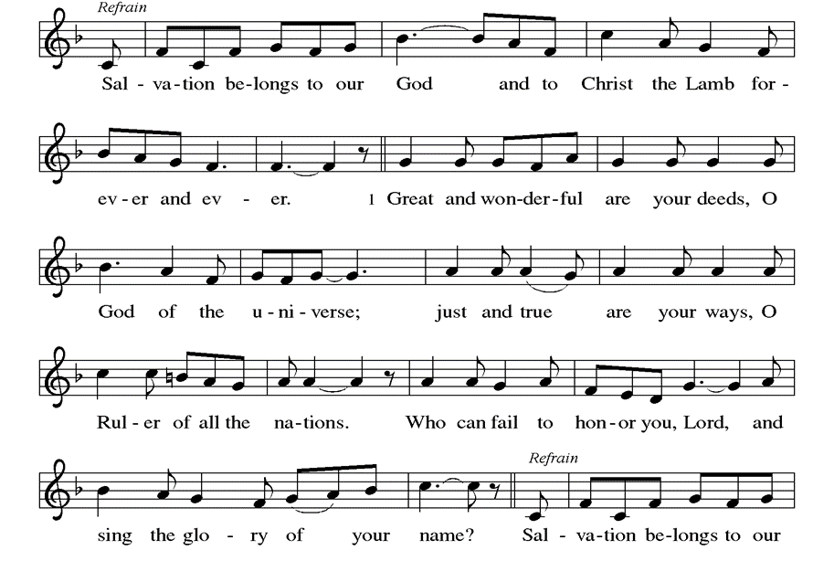
Canticle of Thanksgiving

THANKSGIVING FOR THE WORD
Let us pray. Praise and thanks to you, holy God, for by your Word you made all things: you spoke light into darkness, called forth beauty from chaos, and brought life into being. For your Word of life, O God, we give you thanks and praise.
By your Word you called your people Israel to tell of your wonderful gifts: freedom from captivity, water on the desert journey, a pathway home from exile, wisdom for life with you. For your Word of life, O God, we give you thanks and praise.
Through Jesus, your Word made flesh, you speak to us and call us to witness: forgiveness through the cross, life to those entombed by death, the way of your self-giving love. For your Word of life, O God, we give you thanks and praise.

Send your Spirit of truth, O God; rekindle your gifts within us: renew our faith, increase our hope, and deepen our love, for the sake of a world in need. Faithful to your Word, O God, draw near to all who call on you; through Jesus Christ, our Savior and Lord, to whom, with you and the Holy Spirit, be honor and glory forever. Amen.

Our Father, who art in heaven, hallowed be thy name, thy kingdom come, thy will be done, on earth as it is in heaven. Give us this day our daily bread; and forgive us our trespasses, as we forgive those who trespass against us; and lead us not into temptation but deliver us from evil. For thine is the kingdom, and the power, and the glory, forever and ever. Amen.

Blessing
Go forth into the world to serve God with gladness; be of good courage; hold fast to that which is good; render to no one evil for evil; strengthen the fainthearted; support the weak; help the afflicted; honor all people; love and serve God, rejoicing in the power of the Holy Spirit. Thanks be to God.

Sending HYMN ELW #685
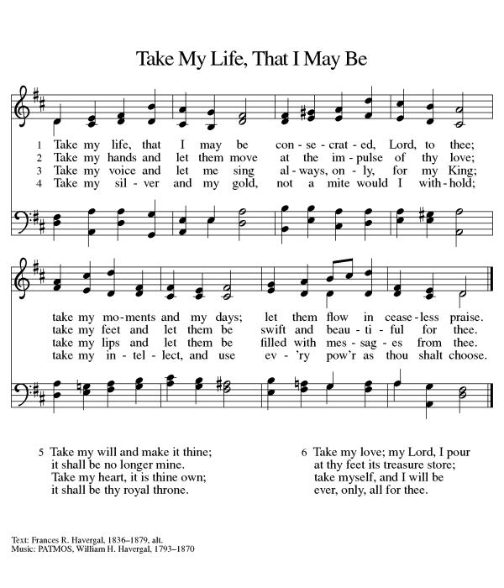
DISMISSAL
Go in peace. Christ is with you. Thanks be to God.

Postlude Improvisation on “Lasst uns erfreuen” Paul Manz
From sundaysandseasons.com. Copyright © 2020 Augsburg Fortress. All rights reserved.

Messiah Lutheran Church
5/31/2020
 | Actual | Actual | Budget
 | May-20 | Jan - May 20 | Jan - May 20
Revenue | $9,981.10 | $81,432.40 | $61,775.00
Expenses | 14,048.07 | 70,900.73 | 69,062.56
Surplus (Deficit) | -$4,066.97 | $10,531.67 | -$7,287.56
Reserve Balance | $80,829.77

Members, Friends, and Family for Whom We Pray Members of Messiah:
Rolland Christenson, Har Shogren, Donna Forsberg, Walli Ellis, Sue Untz
Friends of Messiah  Donna Stejksal  Denise  Suzi Gentine  Bill Stephenson  Dawn  CJ Griffith’s  Bryan Otte | Daniels' friend  Pari Ford’s mother  Paul’s sister-in-law  Joy Janis’s brother  Sharon Hoffman’s Daughter  Carla Wilson and Corey Griffith’s brother  Chris Reinert’s brother | Erin Erb  Stephani White  Karla Goewert  Orin Shogren  Daniellle VanDeVyvere  Bruce Butler  Krista Bahler  Betty Finney  Meghan Presley | Friend of Sherry Peterson  Betty Holcombe’s daughter  Friend of Kirsten Bruce  Har’s brother  Robbie Peterson’s granddaughter  Mary Jo Roch  Betty Peterson’s Niece  Sharon Hoffman’s friend  John & Margaret Presley’s daughter
Serving the U.S.A.
Alex Klapp Betty Russin’s grandson Vicki Charboneau Elaine Eller’s granddaughter
Ben Youngquist S Hoffman’s nephew Jeremy Guy Hensley’s son-in-law
Luke Hammontree Daniel’s grandson T.J. Paulsen Barb Malm’s child

Serving the U.S.A. Overseas Seminary
Daniel & Miranda Norland Randy/Gretchen’s son & wife Kaylie Ines

Please pray for all affected by Covid-19: Healthcare workers/administration/staff, residential staff and residents, those who seem unaffected and those who are currently aware they are infected and are fighting the virus. As well, we pray for all who are being economically negatively affected by the virus and it’s social disruption

Announcements:

Dala Pantry This week marks our third full week of being open and serving the people of the USD400 area.
We have been helped 33 households in our three weeks. We anticipate that as word of the Pantry gets out, that number will go up. Thank you for your prayers and support around this ministry of our congregation. Please also pray that it will be received into the TACOL umbrella in the next year so that it can be a consistent blessing to the community.
If you want to contribute to the Pantry, time can be contributed by calling Alisa and getting on the calendar. If you want to contribute money, please make your donation to Messiah Lutheran and designate the Dala Pantry. If you want to contribute food items, we are asking you to bring canned meats (tuna, chicken, Vienna sausages), pickles, mayonnaise, peanut butter and jelly.
It seems this ministry is being well received in the community as we have had monetary and food donations from many people. Please pray that it becomes a sustainable, consistent blessing to the people in the USD400 catchment area and that we can be God's hands and feet, following the command of Jesus to "feed my sheep." (John 21: 15, 17).

So You Want to Talk about Race by Ijeoma Oluo is being discussed through three different gatherings weekly. If you want to participate in this book study, please let Pastor or Alisa know. The times, once weekly, are Mondays at 10:30 at Bethany Lutheran, Wednesdays at 7:30 at MELC and Thursdays at 1 p.m. at MELC. Pastor Chris and Pastor are leading the 8 week study. You are welcome to join. Pastor has one copy left for purchase. As well, the book is available digitally and through Amazon.

Youth Group Fund Raiser: please keep in mind that the youth are still receiving donations for their initial fundraiser for the National Youth Gathering in 2021! You can give online or through the office. They are believing and hoping and trusting that the National Gathering will happen!

